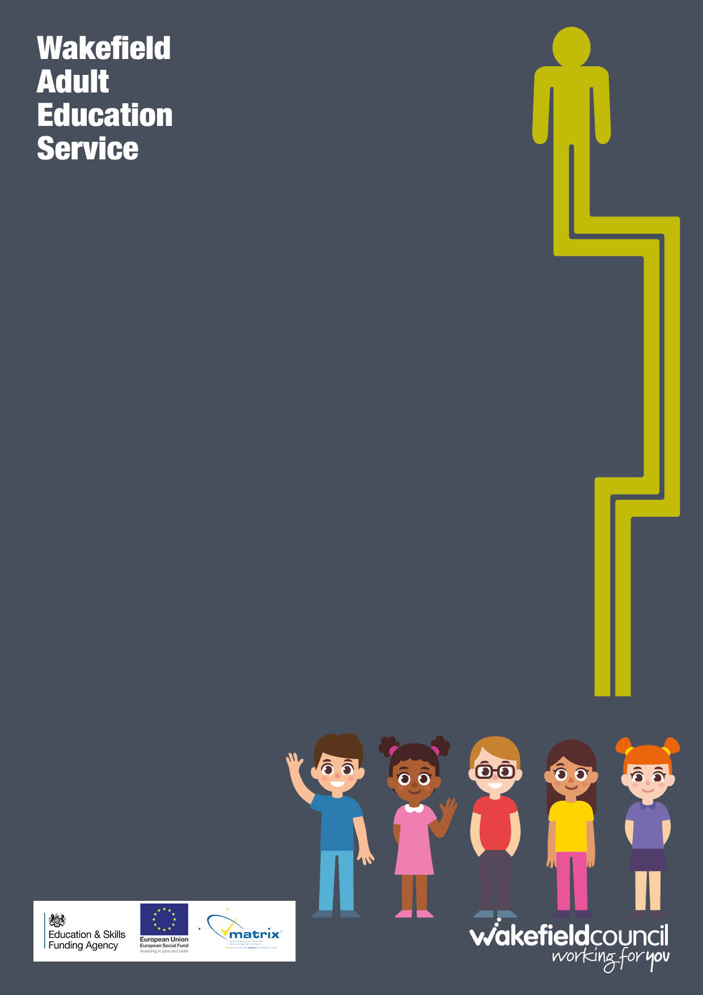

Community Volunteering

What will I learn?

- The role of a volunteer within a voluntary organisation
- The activities of voluntary organisations
- The skills required to be a successful volunteer
- The regulatory frameworks that may apply to being
A volunteer.

Who is it for?

Learners who are aged 19+ who are wanting to gain an understanding and prepare for a role within a voluntary organisation. You may be entitled to a free course.

Important information about your course:

Part 1 of the course is for 4 weeks followed by the option to progress to Part 2 qualification course for 8 weeks. Your tutor will discuss this with you.

Where and when will it take place?

This course will take place at Manygates Adult Education Centre for 2 hours, you attend your lesson on a weekly basis.
What do I need to bring with me?
Pen and notebook.
A basic folder to keep your work in.

How is the course assessed?

Part 1 will have personal learning outcomes that will be agreed with you.

Part 2 you will to compile a portfolio of evidence which will include some written assessments therefore a good level of written English is needed. The awarding body for this qualification is NCFE.

Homework
Your tutor will be setting you tasks to complete each week at home
Punctuality and Attendance
It is important for you to be committed to your learning by having good attendance and punctuality

How do I enrol?
For further information or to book on this course please contact: Manygates Adult Education Centre Telephone: 01924 303302 | Email: manygates@wakefield.gov.uk

