Free menopause sessions
Further information

Please see details below for three different sets of health and wellbeing sessions taking place in West Yorkshire and our neighbouring integrated care systems (ICSs).

All sessions are free to attend and are open to anyone working and/or volunteering in health and social care across West Yorkshire.

- Menopause-focused health and wellbeing sessions in West Yorkshire

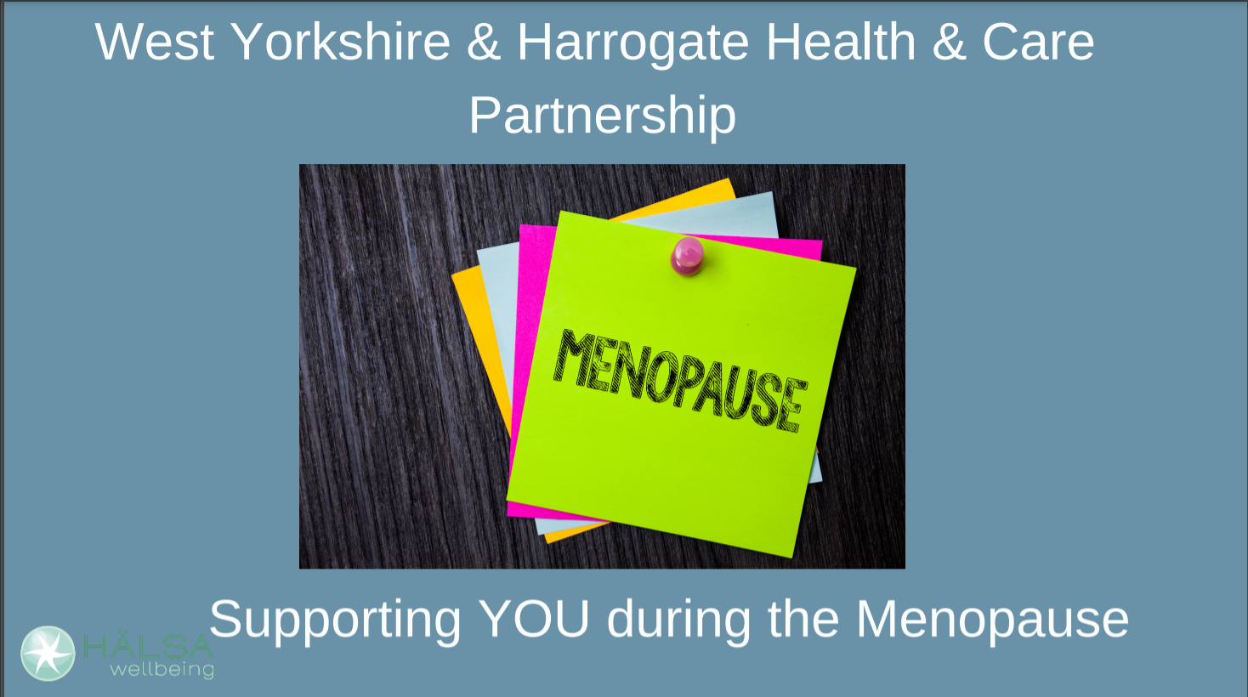

World Menopause Day takes place on Monday 18 October 2021 and sees events held internationally throughout the rest of the month to raise awareness around this transitional stage for women.

It is a fantastic opportunity for those who are affected by the menopause, those who aren’t affected and wider health and care professionals to work together to raise awareness and look at ways to support people impacted by this experience.

During the week commencing Monday 18 October 2021, Halsa will be running a number of wellbeing sessions linked to the menopause on behalf of our ICS.

There are 50 places available on each of the following sessions (all held virtually):
- Reflexology and self-care to support during the menopause
Tuesday 19 October 2021, 9-10am
- Support during the menopause
Tuesday 19 October 2021, 2-3pm
Wednesday 20 October 2021, 10-11am
- Why bone health is important during the menopause
Wednesday 20 October 2021, 2-3pm
- Self-care during the menopause
Thursday 21 October 2021, 12-1pm
- Menopause drop-in group
Thursday 21 October 2021, 2-3pm
- Nutritional support during the menopause
Friday 22 October 2021, 10-11am
- Sleep and how to cope with menopausal symptoms impacting on sleep
Friday 22 October 2021, 2-3pm

You can book your place or find out more about the Halsa menopause sessions online.

- Menopause-focused awareness session aimed at partners, family members, friends and colleagues wishing to support someone going through the menopause

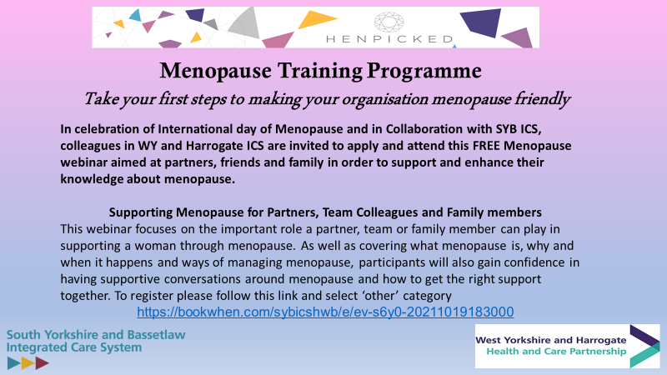

South Yorkshire and Bassetlaw ICS has kindly offered places on its next session to all health and social care staff and volunteers in West Yorkshire.

The session is run in partnership with Henpicked and will focus on helping partners, friends, family members and colleagues to support someone going through the menopause.

The sessions is taking online as follows:
- Supporting menopause for partners, team colleagues and family members
Tuesday 19 October 2021, 6.30-7.30pm

You can book your place and find out more about the Henpicked session for partners, family members, friends and colleagues supporting someone going through the menopause online.

A big thank you to colleagues at South Yorkshire and Bassetlaw ICS for extending the invite.

- Menopause-focused discussion session with Kaye Adams, TV presenter, journalist and author and Dr Shahzadi Harper – “let’s all talk about the menopause”

Humber, Coast and Vale ICS has kindly offered places on its next session to all health and social care staff and volunteers in West Yorkshire.

“In conversation with Kaye Adams and Dr Shahzadi Harper – let’s all talk about the menopause,” will include a discussion around the perimenopause, the menopause and the way menopause is managed and perceived.

The session will also discuss how the menopause can have an impact on our lives and those of the people we live with or work with and what we can do to support ourselves and those around us who are impacted.

The event is free and will take place online as follows:

- “In conversation with Kaye Adams and Dr Shahzadi Harper – let’s all talk about the menopause”
Thursday 21 October 2021, 1pm

You can book your place to the menopause discussion with Kaye and Dr Harper online.

Join Kaye and Shahzadi on 21st October at 13:00 to discuss how the menopause can have an impact on our lives and those of the people we live with or work with and importantly what we can do to support ourselves and those around us who are impacted by the menopause.
To book on this session please register via this link: https://forms.office.com/r/BsTw82LFk4

